#### DATE: 30/11/2021

LIFE DIME

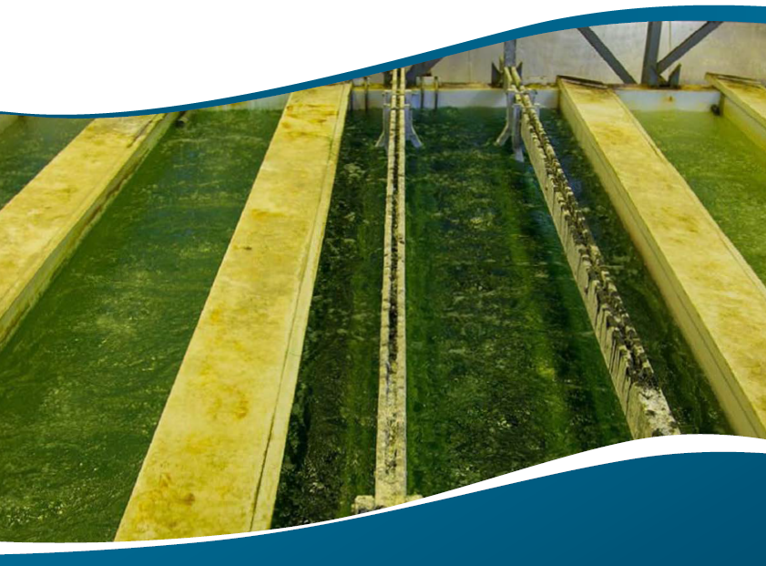

#### LAYMAN’S REPORT

* LIFE16 ENV/ES/000410

DEMONSTRATION OF AN INNOVATIVE TECHNOLOGY FOR THE MINIMIZATION OF THE ENVIRONMENTAL IMPACT OF METAL FINISHING PROCESSES

THE PROJECT PARTNERS

## COORDINATOR



CONDORCHEM ENVITECH SL

Suissa 32

08338 Barcelona (Spain)

condorchem@condorchem.com

www.condorchem.com

¨ Management of the Project

¨ Monitoring and validation of the HCl recovery

¨ Monitoring and validation of the Zn recovery

¨ Monitoring and validation of the iron sulfate recovery

¨ Connection with costumers

¨ Commercialization

¨ Demonstration of the system in Spain

¨ Design, supply and implementation

## PARTNER

ECO-TECHNO SRL

Via del Lavoro 42

20874 Busnago MB (Italy)

info@eco-tchno.it

www.eco-techno.it

¨ Management of the Marketing

¨ Technical advisory

¨ Design, supply and implementation

¨ Communication management

¨ Demonstration and dissemination of the system in Italy

THE PROJECT PARTNERS

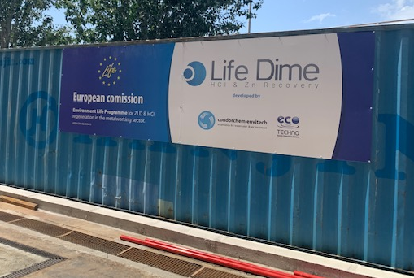

The LIFE DIME Project has received funding from the LIFE Programme of the European Union.

Any communication or publication related to the Project made by the beneficiaries jointly or individually in any form and using any means, reflects only the author’s view and CONDORCHEM or ECO-TECHNO are not responsible for any use that may be made of the information it contains.

The LIFE DIME project is an initiative backed by the EU through its LIFE Programme, under the Environment and Resource Efficiency sub-programme. LIFE Environment and Resource Efficiency aims specifically at contributing to the implementation, updating and development of European Union environmental policy and legislation, including the integration of the environment into other policies, thereby contributing to sustainable development. Furthermore, actions financed must have a European added value and be complementary to those actions that can be financed under other European Union funds during the period 2014-20. LIFE DIME was a 51 months project, whose main objective was to validate an innovative solution for treating the wastewaters derived from metal industry finishing activities, characterized by its high contaminant load and toxic condition. LIFE DIME technology is able to recover valuable raw materials (>550,000 € annual cost-savings per plant) from a hazardous waste-stream produced in high quantities in Europe (380,000 tonnes/year). Thus, it is aligned to European Union environmental policies such as the EU Water Framework Directive (WFD), the Industrial Emissions Directive 2010/75/EU (IED) or the Surface Treatment of Metals and Plastic (BREF), among others.

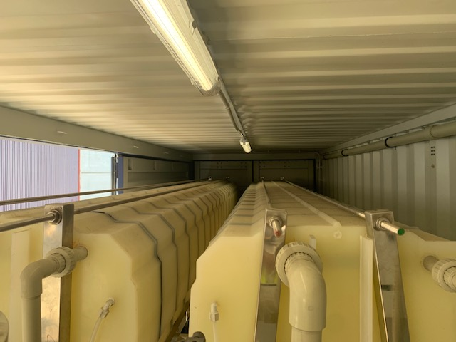

# PROJECT OVERVIEW

THE PROJECT

## OVERALL GOALS

The general objective was to validate an innovative solution for treating the wastewaters derived from metal industry finishing activities, characterized by its high contaminant load and toxic condition. LIFE DIME technology is able to recover valuable raw materials (>550,000 € annual cost-savings per plant) from a hazardous waste-stream produced in high quantities in Europe (380,000 tonnes/year).

This general objective was achieved through the following specific objectives:

· To offer a Zero Liquid Discharge (ZLD) process capable to reduce the potential environmental damage of Spent Pickling Liquor (SPL) and Spent Strip Liquor (SSL) from pickling and galvanizing operations respectively, with no further sludge generation.

· To mitigate the hazardous condition of metal finishing pickling wastewaters derived from removing oxide coatings from metal, by regenerating the 99% (594 t/year) of the hydrochloric acid (HCl) used to perform pickling operations. LIFE DIME solution recovers both free and combined HCl contained in SPL and SSL, reducing the costs and environmental concerns associated to neutralization and disposal operations.

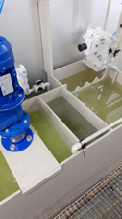

· Besides the acid concentration, SPL and SSL contain dissolved metal salts of iron, chromium, copper or zinc, among others. One of the main aims of the project is to recover up to the 99% of metal salts contained in SPL and SSL, mainly:

* To recover ferrous sulphate heptahydrate (Fe2SO4·7H2O) crystals (284 t/year) for commercialization as a by-product (fertilizer).
* To recover zinc chloride (ZnCl2) (41.5 t/year) for reuse in the galvanizing process.

· To evaluate the feasibility for full-scale application of the solution in an actual galvanizing plant producing 480 m3/year of SSL hazardous wastewaters.

· To evaluate the feasibility for full-scale application of the solution in an actual galvanizing plant producing 480 m3/year of SSL hazardous wastewaters.

· To elaborate business models establishing the adequate strategy to approach the European market with a commercial solution for ferrous industries (steel), but also replicable to non-ferrous ones (aluminium, copper or zinc) and to others metal surface treatments (electroplating, coating with oxides, thermal spraying, chromate coating, among others)

· To disseminate the project results through LIFE DIME website as the main communication tool, but also throughout a communication campaign with the support of the media and press to spread the project results among every targeted audience.

THE PROJECT

# MAIN PROJECT ACTIVITIES

THE PROJECT

* Design and implementation of the demonstration plant: Efforts in this action were to design and to build a demonstrative plant for treating galvanizing plants’ wastewaters in real conditions.
* Process start-up: This action comprehends the starting-up of the 4 principal stages of the process: 1) Pre-treatment module; 2) Reaction module; 3) Separation module; 4) Distillation module.
* Process optimization: During pickling process, acids are consumed and metals dissolved in the Pickling liquor resulting on a spent liquor containing a high content of acids (HCl) and metals (Fe and Zn). This action was focused on boosting HCl, Fe and Zn recovery rates up to a 99%.
* Demonstration plant evaluation: An analytical campaign demonstrated that the main aims have been achieved in relation to the effluent quality, the energy consumption and the cost-efficiency.
* Replicability and Transferability Strategy: This action was focused on developing the best strategy to replicate and transfer the project results during and after its implementation. These activities went beyond dissemination, transfer of knowledge and networking as they were focused on facilitating the replication and/or transfer of the project’s results and experiences to other countries.
* Monitoring of the impact of the project actions: Based on the evaluation of the demonstration plant, monitoring had a twofold approach: environmental benefits and socioeconomic impact of the project.
* Dissemination planning and execution: This action was divided into two different tasks: Networking with other projects and Dissemination planning.
* Overall project management: This action included the overall management of the project, necessary to assure the communication flow and reporting to the EC, project follow-up, decision making procedures or interaction with third parties. The After-LIFE Plan was also included in this action.

### SCHEDULE

### 

### 

# RESULTS

RESULTS

## ZN EXTRACTION AND RECOVERY

The results reflect a total recovery about 97%, only the 3 % of the zinc remains in the system.

### HCl RECOVERY

The results reflect a total recovery about 99%, only the 1 % of the HCl was lost.

### IRON SULFATE RECOVERY

The results reflect a total recovery about 99%, only the 1 % of the iron remains in the system.

RESULTS

### EVALUATION OF THE COST & PROFIT

The cost of treatment per liter of acid is approximately €0.171, while the benefit obtained from saving raw materials and the sale of by-products is around €0.114 per litre. This represents a real cost of **€0.057**.

DISSEMINATION

# DISSEMINATION

A key aspect of the project activities was the dissemination of the know-how to the sector, technicians, administrations at all scales. The main communication tools and dissemination activities addressed in the project were:

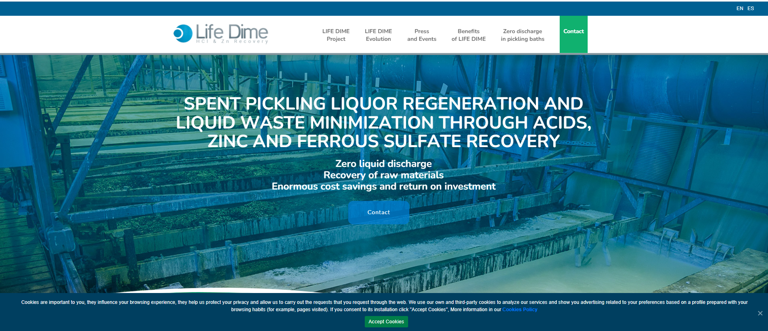

WEBSITE

Site to discover the Project and communication with the world.

The web was one of the main points for the communication.

**https://lifedime.eu/en/**

VISITS

A key point was to show a functioning plant to all the galvanizers and sector professionals.

**Visitors number: >15 (**due to the pandemic situation the number was low)

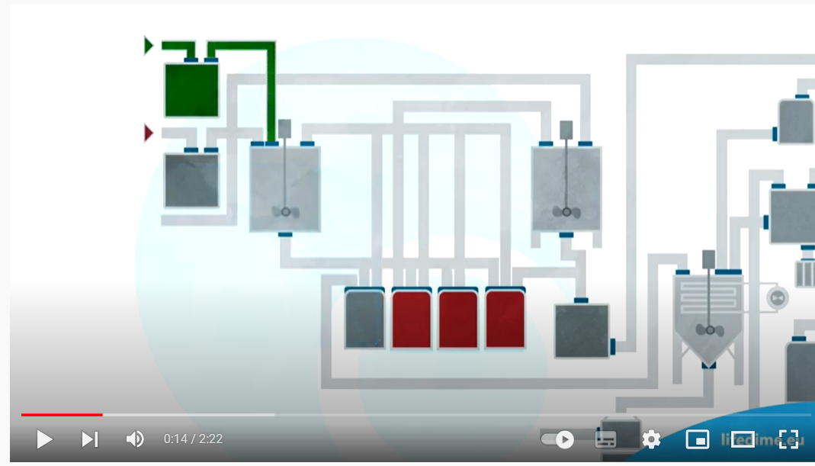

VIDEOS

In order to explain the technology, training videos were made.

<https://www.youtube.com/watch?v=nN_5eh7GgPQ&ab>

<https://www.youtube.com/watch?v=rcYURncNm3g>

LIFE DIME PROJECT—DEMONSTRATION OF AN INNOVATIVE TECHNOLOGY FOR THE MINIMIZATION OF THE ENVIRONMENTAL IMPACT OF METAL FINISHING PROCESSES

DURATION: September 2017—November 2021

PROJECT BUDGET: 1,509,065 €

EU CONTRIBUTION: 748,839 €

LIFE DIME is co-financed by the LIFE program of the European Union. (Grant Agreement No. LIFE16 ENV/ES/00041). This document expresses only the opinion of the author hence the agency is not responsible for any possible use of the information herein contained.

More information at

condorchem@condorchem.com

info@eco-techno.it

info@lifedime.eu